Sanos Bootstrapping instructions

# Sanos Github to Windows 8.1 Hyper-V virtual client

## Fix Github issues

* Default windows makefile to Visual Studios 2010
* Create 2 missing directories in win folder(This prevented the iso from installing correctly)
  + /mnt
  + /tmp

## Compile in windows using Visual studio 2010

* Set up compiler

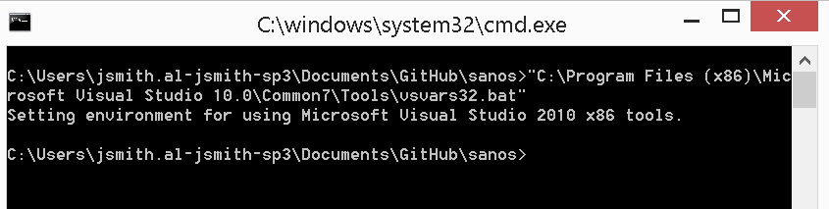

* Recompile sanos

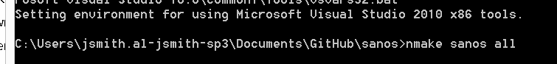

* Recompile cross assembly toolchain
  + bin\make -f Makefile.cross
  + 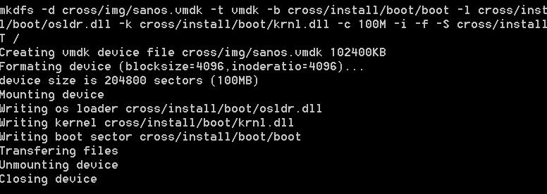
* You now have bootstrap files (we are interested in the iso file sanos.iso)

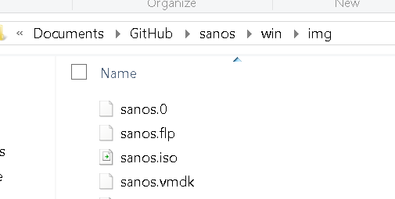

## Now we use this iso and create a Hyper-V Virtual Machine

* Move the iso to a Hyper V folder

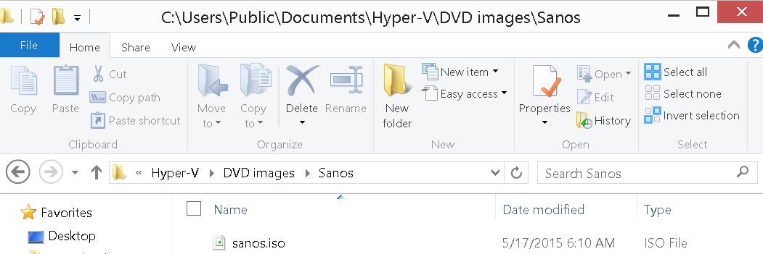

* Create a new Virtal machine like this
  + Set up networking
  + 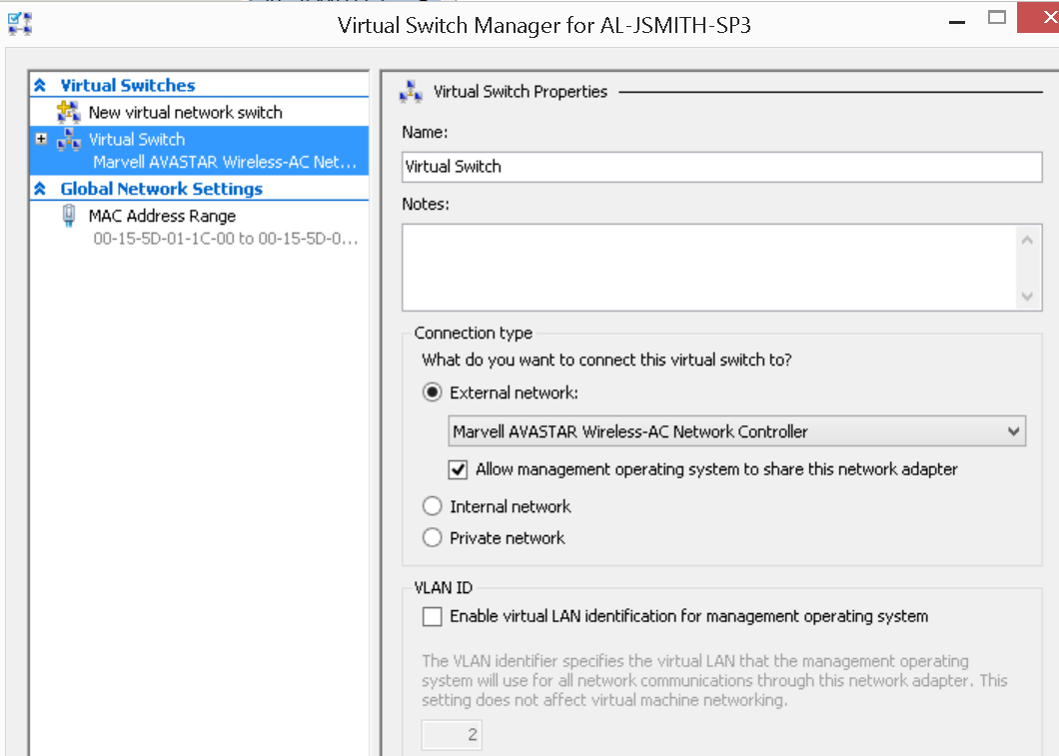
  + 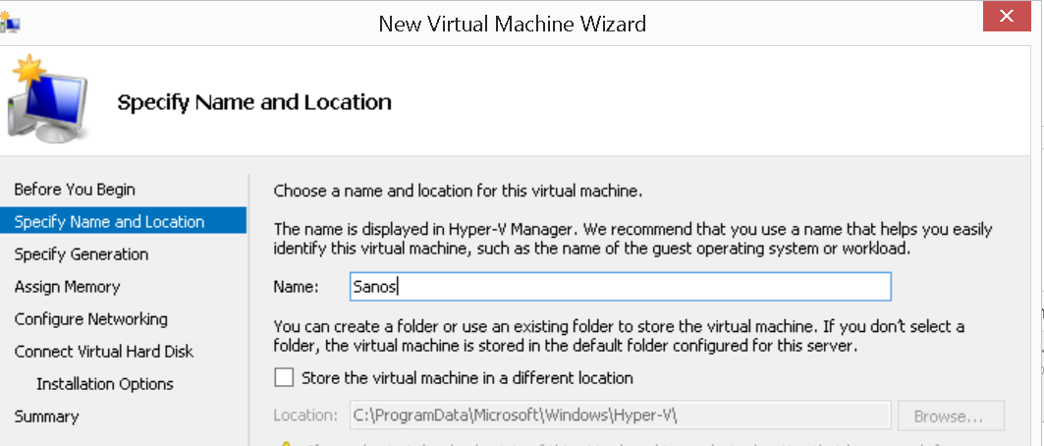
  + 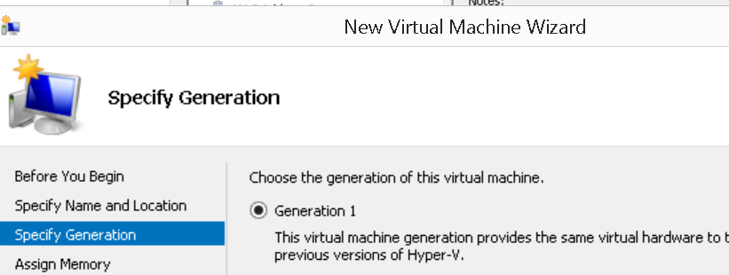
  + Leave the memory at 512
  + Attach the virtual switch
  + Create a 1 gig (min system)
  + 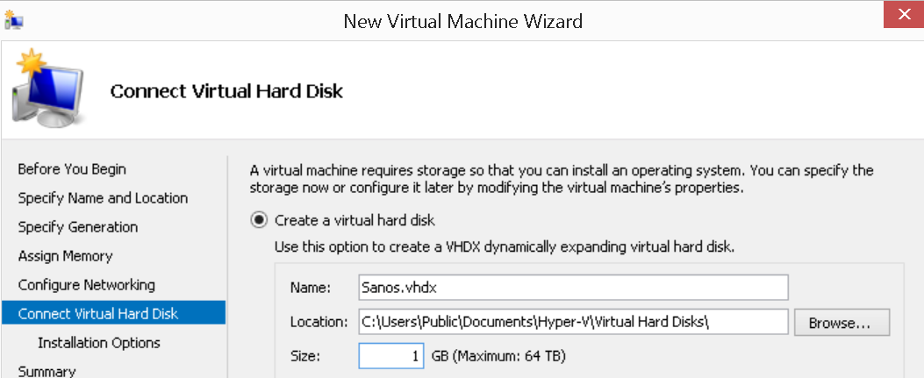
  + Add CD drive pick your sanos.iso file
  + Now the settings
  + Delete the network and add a legacy network (pick the virtual switch)
  + Boot order CD first
  + Now Start the virtual machine and connect
  + 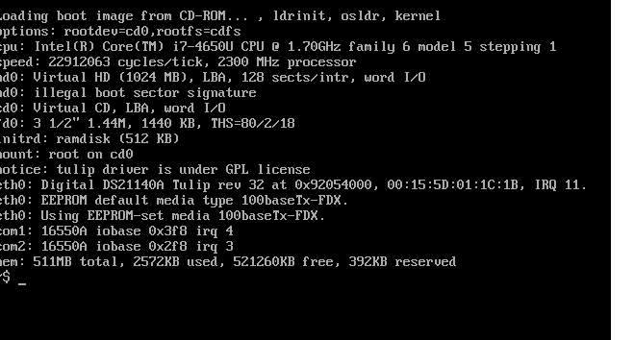
  + Now we fdisk the virtal hard drive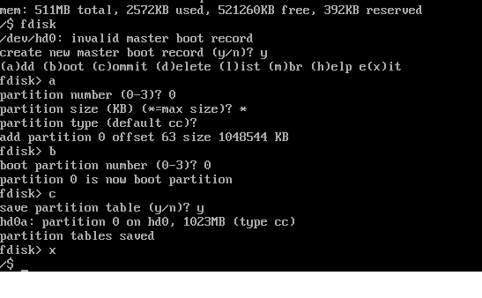
  + Now we install sanos to the hard drive by typing setup
  + 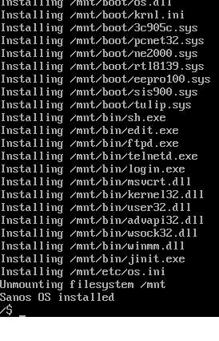
  + Change the boot order to the hard drive and reboot
  + 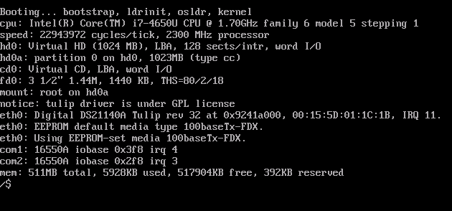

Done